(Approx. 1113)

HD TV Technology and Content – What’s New?
By Tom Burt, Vice President
Sun City Summerlin Computer Club
https://www.scscc.club
tomburt89134 (at) cox.net

One of my occasional club seminars is a review of High-Definition TV technology and sources of HD content. I decided to convert my seminar slide show to an article and update it to reflect the latest 2020 offerings.

HD TV Technology 2020
In 2020 virtually all larger sets (50 inch and up) for sale at retail outlets and on the web support the Ultra HD (aka 4K) resolution of 3840 (horizontal) by 2160 (vertical) pixels. This gives a picture aspect ratio of 16 by 9 and a total pixel count of about 8.3 million. There are some high-end sets with a so-called 8K resolution of 7680 by 4320 and a total pixel count of about 33.2 million.

Most newer sets also feature a wider color depth: 1024 levels each of red, green and blue, giving about 1 billion possible distinct colors. Most sets also feature High Dynamic Range which increases contrast range – making blacks darker and whites brighter.
Most HD TVs also include Smart TV features that make the set able to stream content from various Internet streaming TV services such as Netflix, Prime TV, Hulu, Apple TV, or Disney TV+.

The predominant screen technology is still liquid crystal (LCD), usually backlit by an array of white light-emitting diodes (LEDs). In HDR sets, these LEDs’ brightness can be varied selective to help darken blacks and brighten whites. Other screen technologies include organic light-emitting diode (OLED) and quantum dot (QDot). Both of these give higher quality pictures but are expensive.

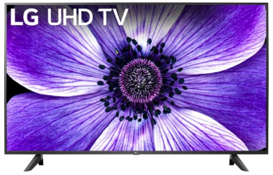
For example, here’s an LG 65-inch LCD (LED-backlit) 4K Smart HDTV with HDR (model: 65UN7000PUD) priced at $500 at Best Buy. Its rating on Best Buy is 4.6 stars.

This is a quality set with lots of features and is likely all you need for a family room set. It has three HDMI input jacks, good for hooking up various external boxes.

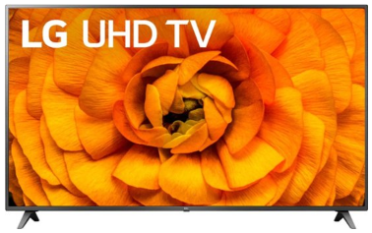
HDTV sets with larger screens, more input jacks, and more Smart features tend to cost more.

For example, here’s an LG 82-inch LCD (LED-backlit) 4K Smart HDTV with HDR (model: 82UN8570PUC) priced at $1500 at Best Buy. Its rating on Best Buy is 4.1 stars.

This is a quality set with lots of features and a good choice for a home theater. It has four HDMI input jacks, good for hooking up various external boxes.

There are now HDTV 4K sets with screens as large as 110 inches.

Hooking Up Your HDTV
Your best results will come if you use high-definition media interface (HDMI) cables to connect various external boxes to jacks on your HDTV. Unless your connections are longer than 10 feet, there’s no need to buy expensive HDMI cables at the big box store. Order the cheap ones from the Internet. Caution, as 8K sets and content become more widespread, you may have to use upgraded cables because they are carrying 16 times as much video data as regular HD content.

You may want to consider wall-mounting your HDTV if it’s 65 inches or larger. If you do, spend the extra money to get a heavy-duty telescoping wall mount with a weight capacity substantially greater than that of your HDTV. The LG 82-inch set above weighs 102 pounds, so it would be no fun to lift, even for two people.
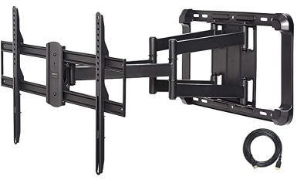
For example, this Amazon Basics wall mount is $79 on Amazon and has a weight capacity of 132 pounds. It was rated 4.6 stars on Amazon.

A wall mount needs to be anchored to the studs in the wall it is mounted on. It may be necessary to mount a plywood panel to the studs of the wall and then screw the HDTV mount to the plywood panel. (i.e. This may be a job for professionals.)

HDTV Makers
The first-tier name-brand HDTV makers include Samsung, Sony, LG, Vizio, Sharp, Toshiba, and Epson (projectors). There are many second-tier and house brand makers whose sets are also of very good quality and generally at better prices.

Where to Get HD and 4K Programming and Content
You can receive digital HD programming over the air from the broadcast TV networks. You need an antenna to receive the digital broadcasts and feed them into the antenna jack on your HDTV or set-top receiver. In Las Vegas, there are about 80 broadcast channels. Many are in Spanish and others may be hard to get because they are weak. There are a variety of indoor antennas, with and without powered amplification. If you can place these in a window, you may get decent reception.

You can also pay for a professional exterior antenna installation, which will deliver a much better signal to the HDTV. Check out Mr. Antenna.

You can pay for HDTV from Cox, DirecTV, Dish, or CenturyLink. These services are reliable and offer a vast array of channels that you can’t get over the air. Their higher tiers can get quite expensive, especially after any promotional rates expire. It becomes an annual ritual to call up your provider and haggle for a reduction from the listed standard rates. Usually, you have to threaten to switch and then their retention representative comes through with a discount for another year.

You can watch HD and even 4K Blu-ray disks if you have a matching Blu-ray player. However, there is very little 4K Blu-ray content for sale. Your 4K HDTV will automatically up-convert any incoming regular standard or HD content to “near 4K” resolution.

You can also stream HD and some 4K content from the various paid Internet streaming services, such as Prime TV, Netflix, Hulu, Apple TV, Disney +, CBS All Access, AT&T TV Now, Sling TV, and YouTube TV. Some offer custom content and some offer a wide array of cable channels. A plus is that you don’t need a special receiver – just an in-house network connection from your TV or a “Smart” box such as a Roku or Fire TV to your Wi-Fi router.

Many of the cable and broadcast networks also make recent episodes of shows available to stream from their websites. If your Smart TV or smart box has a web browser app (most do), you can go to the network’s website and stream those shows through the Internet to your HDTV.

Commonly a household will opt for a mix of free and paid solutions to satisfy their needs for TV information and entertainment. A website that’s very helpful for deciding what mix of services you need is Suppose TV (https://supposetv.com). You enter a list of “must-have” channels and the website will display which services offer that set of channels.

